1.illustrate
The development environment for testing this routine is Delphi 2007 for Win32, and it requires the use of DLL libraries in x86; The running environment for routine testing is Win7. The DLL library version used in the routine is V1.17, and the firmware version needs to be at least V2.07 (otherwise there may be issues receiving data). The specific version information can be viewed through the CANFDToolPro software or through this test demo. As shown in the following figure.
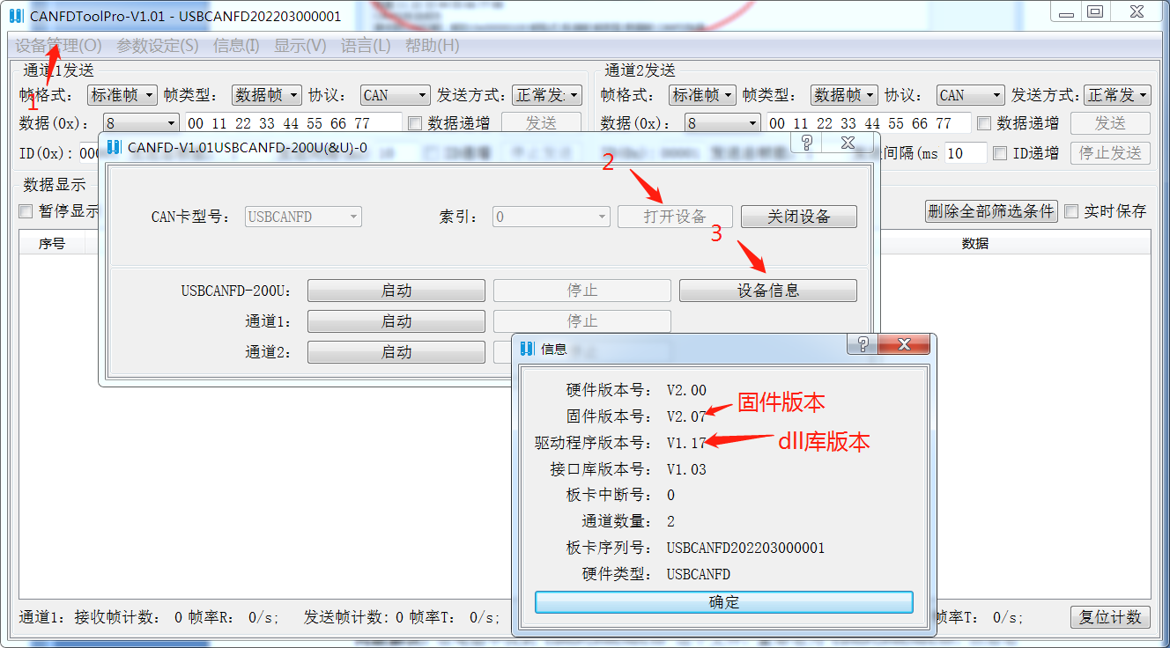
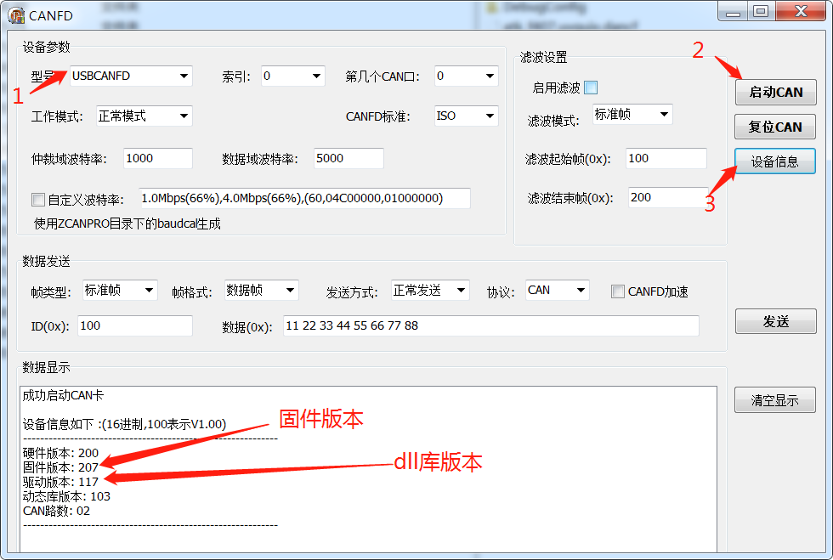

2.Sending and receiving CAN frames
After selecting spontaneous self collection, you can directly see the received data, as shown in the following figure.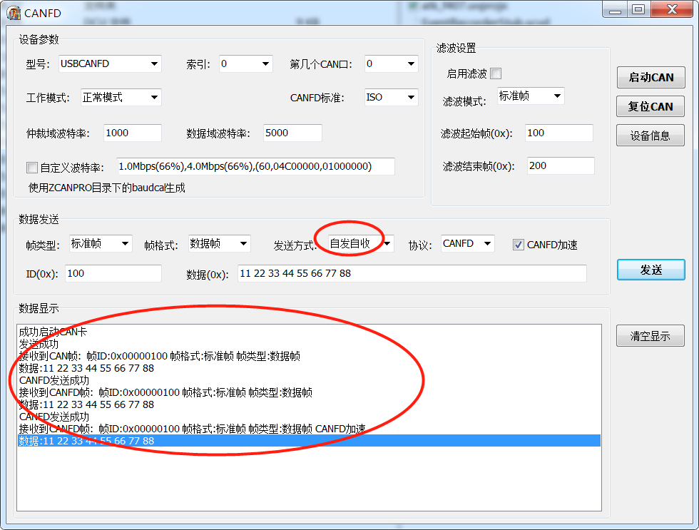

3.Regarding the issue of the EditorLineEnds.tr being occupied during the second opening of Delphi 2007.
Problem phenomenon: The first time you open the software (including restarting the computer), you can use the software normally. After closing, opening the software again will report "EditorLineEnds.ttr occupied". At the same time, the background process bds.exe * 32 of delphi2007 will always exist in the task manager.
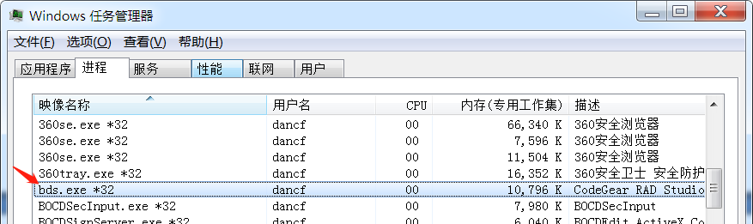

Problem solving: Find the file EditorLineEnds.tr on your computer, rename it to EditorLineEnds.ttf, and then right-click ->Install. Finally, restarting the computer will solve the problem. I verified OK on my own Win7 computer.
PS: This issue is caused by Microsoft's system upgrade package, and the specific principle can be explored by Baidu Search.

